**Q1. Which are the top three variables in your model which contribute most towards the probability of a lead getting converted?**

Answer:

Three important variables are:

* **What is your current occupation_Working**
* **Lead Origin**
* **Lead Source**

**Q2 What are the top 3 categorical/dummy variables in the model which should be focused the most on in order to increase the probability of lead conversion?**

Answer:

**Lead Origin_Lead Add Form**

**What is your current occupation_Working Professional**

**Lead Source_Welingak Website**

Q3 X **Education has a period of 2 months every year during which they hire some interns. The sales team, in particular, has around 10 interns allotted to them. So during this phase, they wish to make the lead conversion more aggressive. So they want almost all of the potential leads (i.e. the customers who have been predicted as 1 by the model) to be converted and hence, want to make phone calls to as many of such people as possible. Suggest a good strategy they should employ at this stage.**

Answer:

**Call people basis on the following features which contribute maximum to convert the lead.**

**The features are in descending order.**

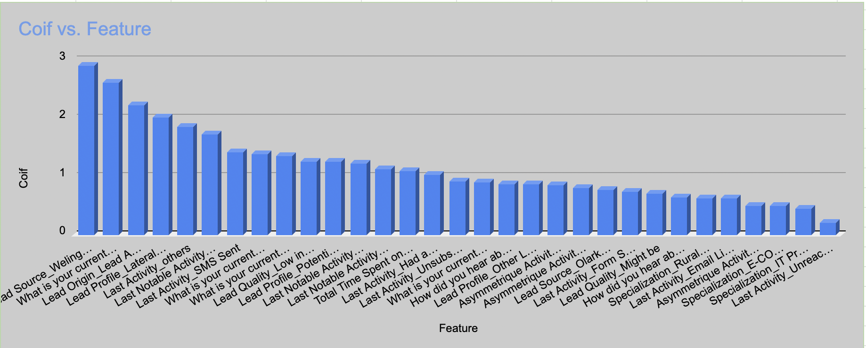

| **Feature** | **Coif** |
| --- | --- |
| Lead Source_Welingak Website | 2.9059 |
| What is your current occupation_Working Professional | 2.6055 |
| Lead Origin_Lead Add Form | 2.2286 |
| Lead Profile_Lateral Student | 2.0143 |
| Last Activity_others | 1.8571 |
| Last Notable Activity_Had a Phone Conversation | 1.7253 |
| Last Activity_SMS Sent | 1.4225 |
| What is your current occupation_Student | 1.3859 |
| What is your current occupation_Other | 1.344 |
| Lead Quality_Low in Relevance | 1.2531 |
| Lead Profile_Potential Lead | 1.2459 |
| Last Notable Activity_Unreachable | 1.2262 |
| Last Notable Activity_others | 1.1185 |
| Total Time Spent on Website | 1.0864 |
| Last Activity_Had a Phone Conversation | 1.0326 |
| Last Activity_Unsubscribed | 0.9201 |
| What is your current occupation_Unemployed | 0.9054 |
| How did you hear about X Education_Email | 0.8666 |
| Lead Profile_Other Leads | 0.8609 |
| Asymmetrique Activity Score | 0.8539 |
| Asymmetrique Activity Index_03.Low | 0.8016 |
| Lead Source_Olark Chat | 0.7722 |
| Last Activity_Form Submitted on Website | 0.7346 |
| Lead Quality_Might be | 0.7079 |
| How did you hear about X Education_Social Media | 0.638 |
| Specialization_Rural and Agribusiness | 0.623 |
| Last Activity_Email Link Clicked | 0.6166 |
| Asymmetrique Activity Index_02.Medium | 0.4945 |
| Specialization_E-COMMERCE | 0.4906 |
| Specialization_IT Projects Management | 0.4492 |
| Last Activity_Unreachable | 0.2072 |
| Last Notable Activity_Olark Chat Conversation | -0.4579 |
| Lead Origin_Landing Page Submission | -0.6378 |
| Asymmetrique Profile Index_02.Medium | -0.6398 |
| Specialization_Hospitality Management | -0.7264 |
| Asymmetrique Profile Index_03.Low | -0.7959 |
| Last Notable Activity_Modified | -0.8591 |
| How did you hear about X Education_SMS | -0.9412 |
| Do Not Email | -1.1058 |
| Lead Quality_Not Sure | -1.1219 |
| Last Activity_Olark Chat Conversation | -1.2087 |
| Last Notable Activity_Email Link Clicked | -1.2274 |
| Lead Quality_Worst | -3.0024 |

**Q4 Similarly, at times, the company reaches its target a quarter before the deadline. During this time, the company wants the sales team to focus on some new work as well. So during this time, the company’s aim is to not make phone calls unless it’s extremely necessary, i.e. they want to minimize the rate of useless phone calls. Suggest a strategy they should employ at this stage.**

Answer:

T**he team should call people who have the following features.**

**1. Leads with Lead Source as Welingak Website.**

**2. Current occupation as Working Professional or Student**

**3. Leads with Lead Origin as Lead Add Form**

**4. Leads with Lead Profile as Lateral Student, Potential Lead**

**5. Last Notable Activity as Had a Phone Conversation**

**6. Leads where last SMS Sent or Had a Phone Conversation**

**7. Lead Quality as Low in Relevance**

**8. Total Time Spent on the Website is the highest**